MORNING WORSHIP SERVICE
Oct 15, 2017

Opening “Hallelu, Hallelu”

Opening Prayer/Announcements

Worship Hymns “Jesus Loves Me” 344
“Victory in Jesus” 426
“Spirit Song”
“How Great Is Our God”
“How Great Thou Art” 10

Offertory

Special Music Bro. David Atwood

300 is our goal!! We are packing today 3pm -5pm There is still a lot to do, so please join us!!
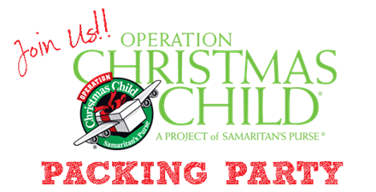

Sermon Bro. David Atwood

Invitation “Turn Your Eyes Upon Jesus” 320

Join us!
The men will cook an awesome breakfast so we can fellowship before Sunday School
No Evening Service Tonight

NURSERY – available for children age 0 to Kindergarten
Christine McManus, Sara McManus
Hostesses/Hosts for Oct Ushers for Oct
Christine McManus, Cissy Atwood Joe Wilson, Joe Daniel,
Dianne Lindemann David Condron, Hugo Breithaupt

Immediate Need Prayer List
Prayer & Request Information

(Please complete name & address information on reverse side)

❑ I would like to speak with the Pastor.

❑ I would like more information on this church.

❑ I have Prayer Requests or Needs

Date:

Permission to Publicize:
Church Bulletin  Yes  No
Email Prayer Chain  Yes  No

Prayer Request:

Prayer For
Name
Address
Phone

Given By
Name
Address
Phone
Please Contact By

❑ Card  Phone  Visit

Comments

Sam Craig, Barbara Komandosky, Marlin Cunningham, Darleen Gravell, Sheila Waggoner, Brenda Johnson (Angie Fisher’s mom)

K s b c

Keeping His Word through Sunday School, Bible Study and Church Attendance/Worship

Sunday School Bible Studies for Oct:

Oct 1st Battle Armor Ephesians 6:10-20
Oct 8th Battle Plan Mathew 4:1-10
Oct 15th Caleb: Unwavering Faith Numbers 13:26-30; 14:6-10,21-24
Oct 22nd Solomon: Unfailing Wisdom 1 Kings 3:3-14; 4:29-34 Oct 29th Ruth: All-In Commitment Ruth 1:1-17

9:45 a.m. each Sunday – A place for everyone

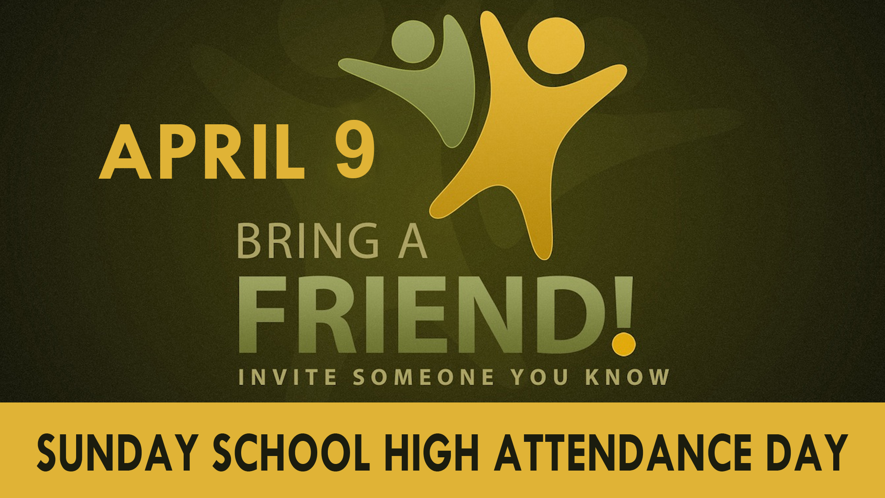
Oct 29

